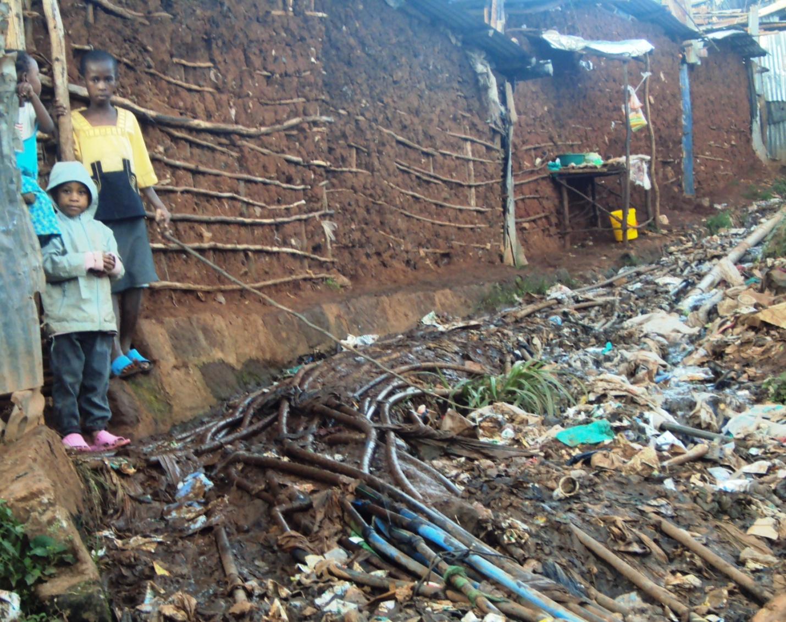

Sphagettin pipes Mathare informal settlement

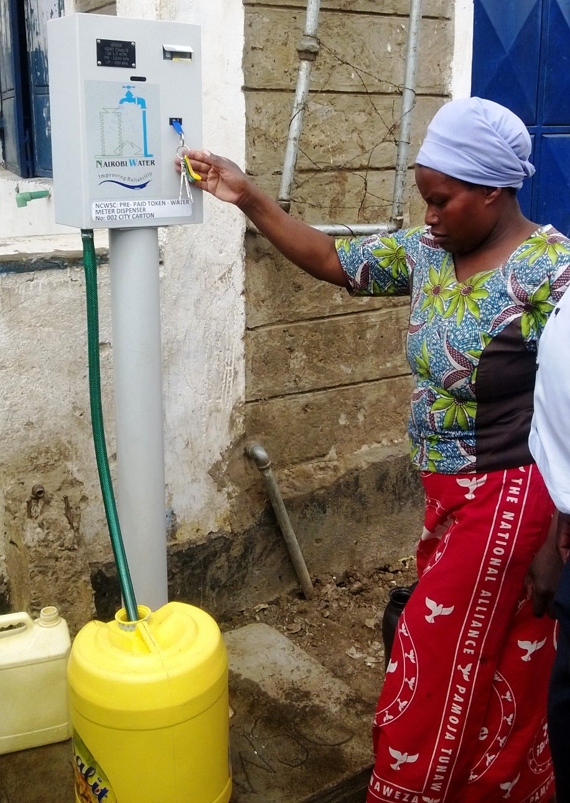
A prepaid meter at Mathare Informal settlement Nairobi. It charges 50cts for a 20ltr water Jeri cane
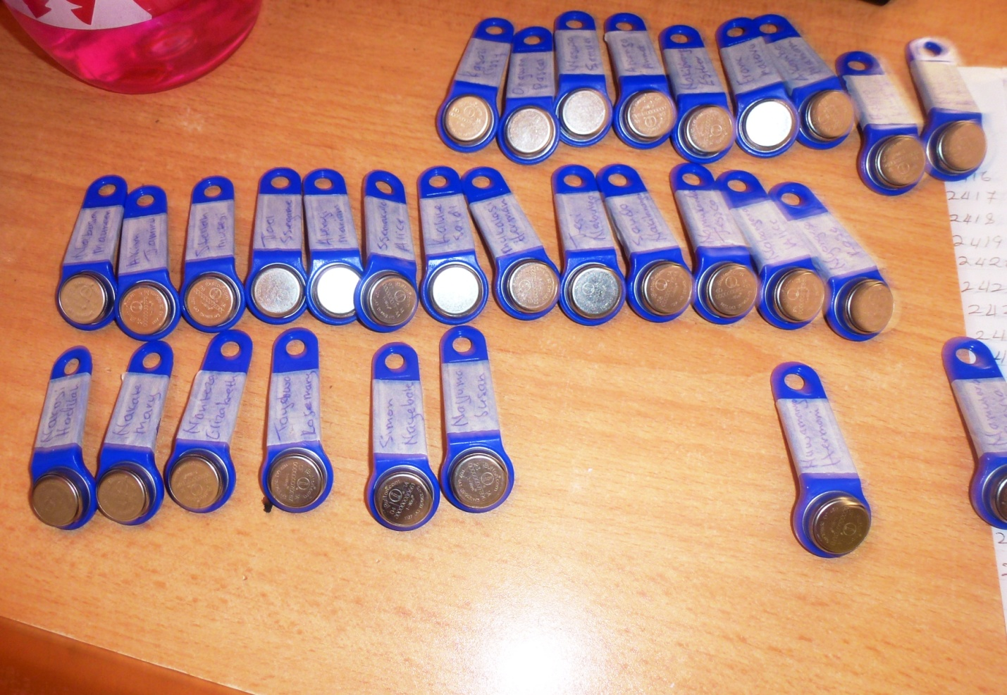

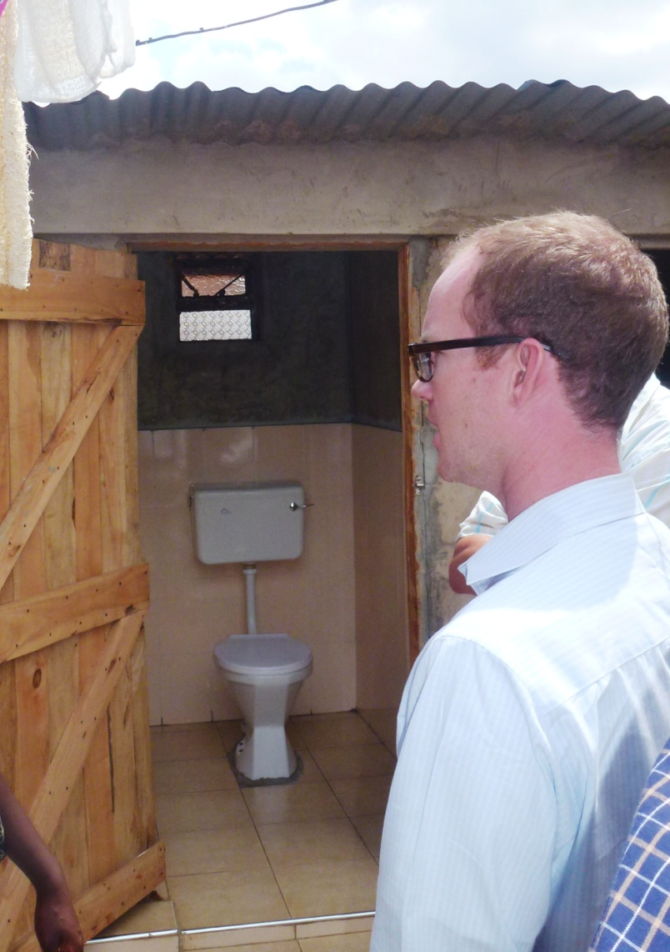
An improved plot based toilet at Mathare mashimoni

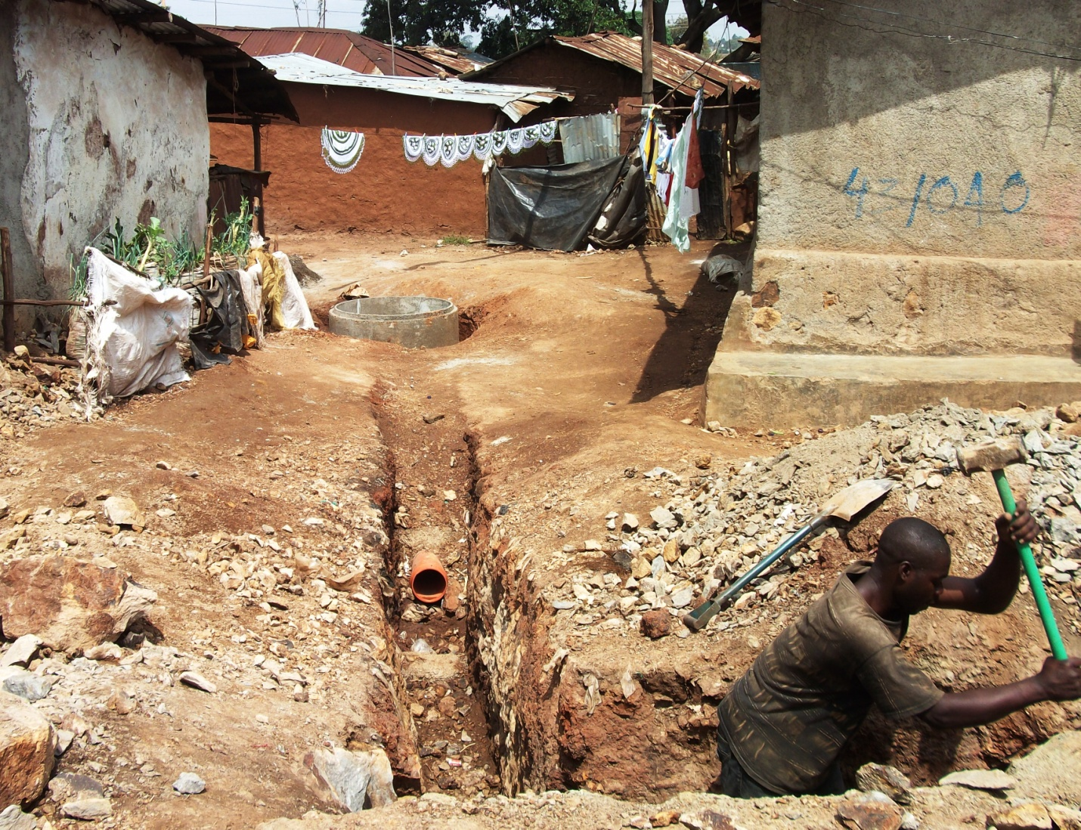
A condominium Sewer project: The sewer has enabled the residents to connect plot based toilets to the sewer line Mashimoni Mathare

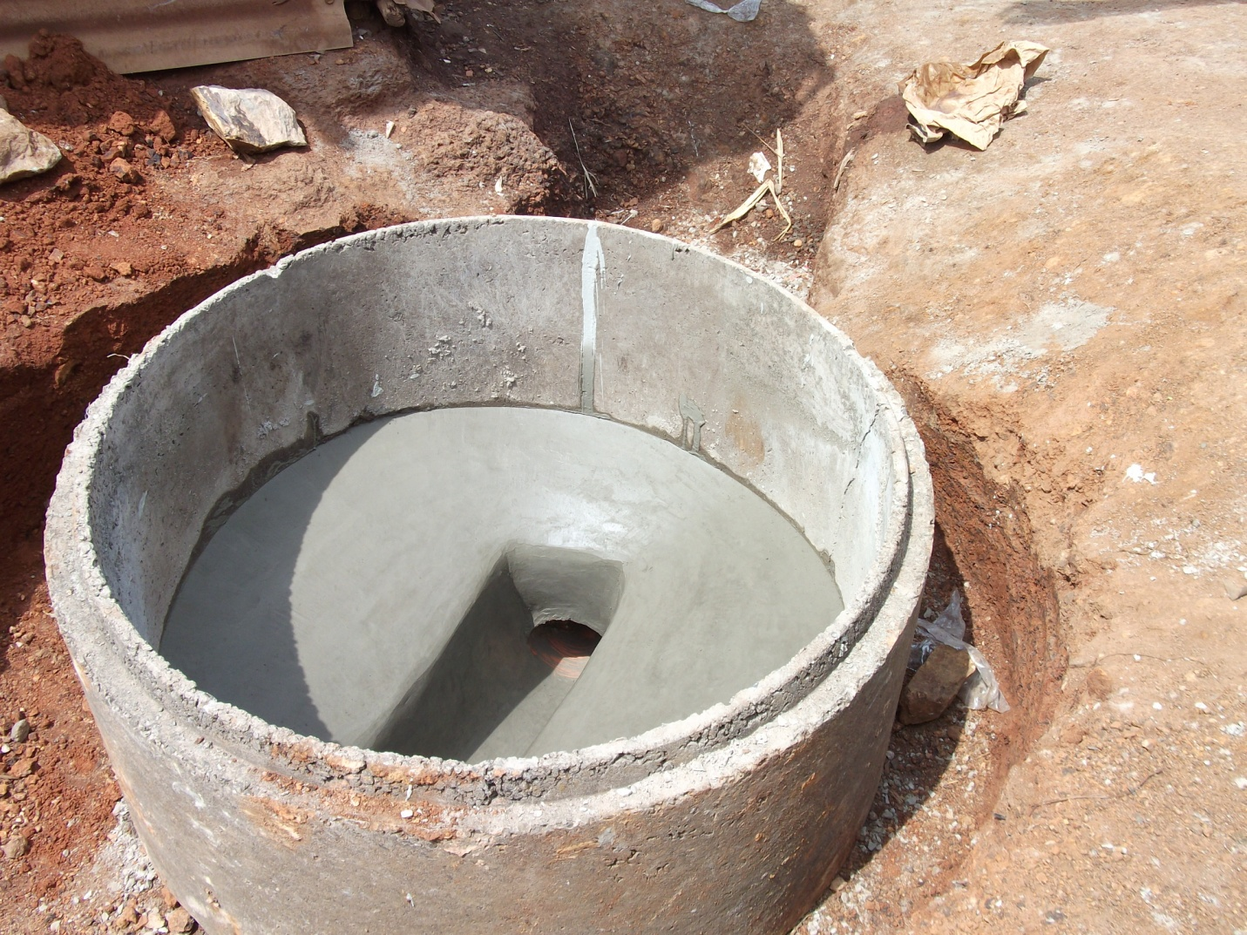
A manhole of a condominium sewer line at Mashimoni

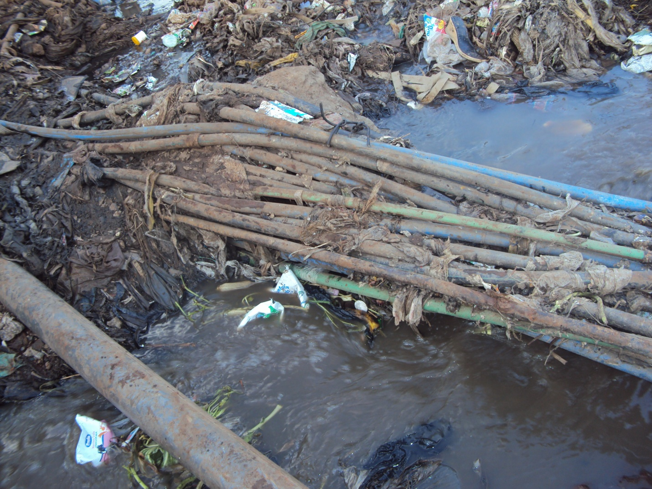

Spaghetti clean water pipes passing over a dirty water river at Mathare River

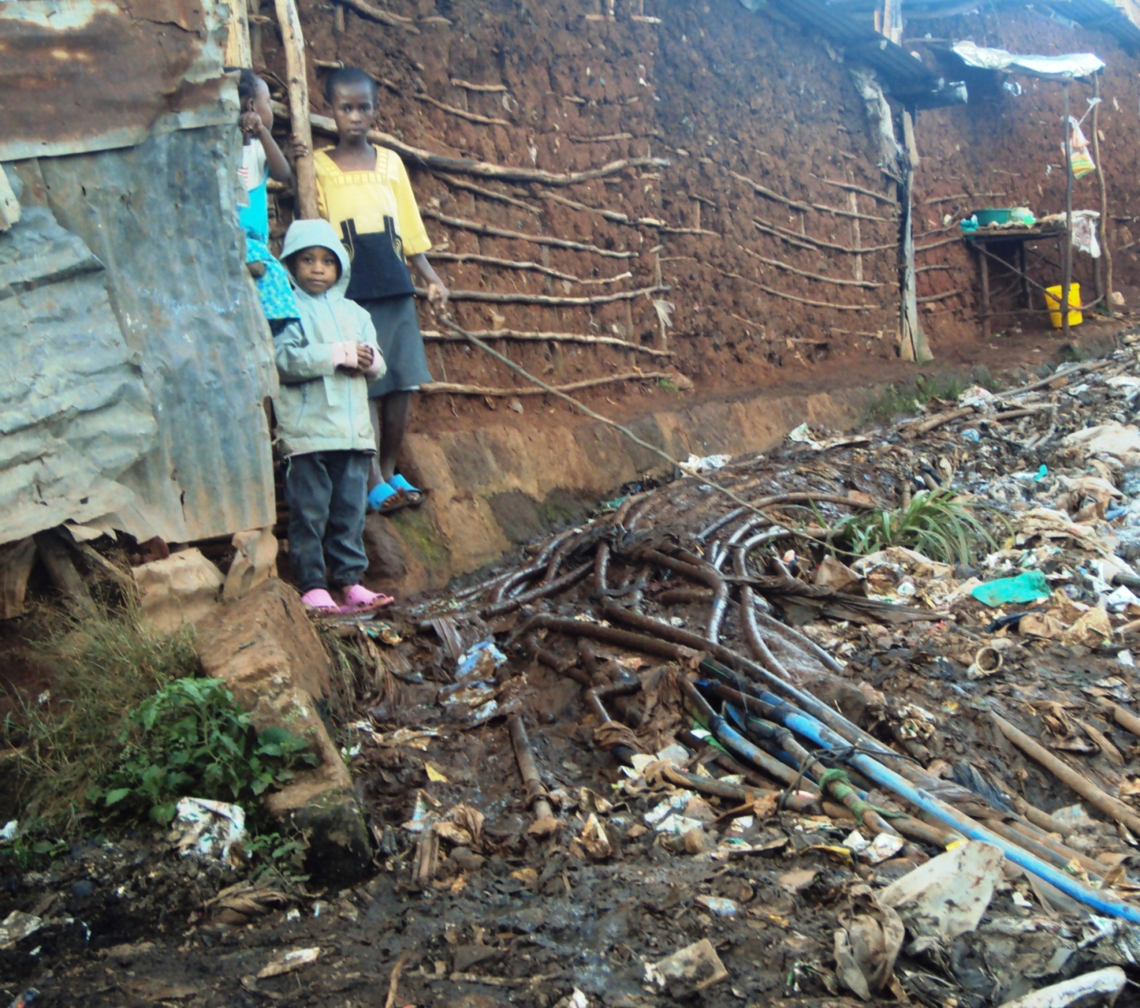

Spaghetti pipes supplying water in Mathare

